**ST GEORGE'S MEDICAL PRACTICE**

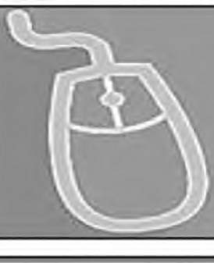

Yarm Road, Middleton St George, Darlington, DL2 1BV Tel: 01325 332022

Website: www.stgeorgesmp.co.uk

Email: stgeorgesmedical@nhs.net

***Welcome* to the first *edition of our newsletter from Sc George's Medical Practice.***

Please note we are closed on Monday 28th May 2018 as it is bank holiday. The surgery will re-open as normal on Tuesday 29th May 2018. Because of this, our late evening surgery will be changed that week to Thursday 31st May 2018.

From 1st April 2018 we will be closed on Wednesday lunch times from 12:30 - 2pm. Or Patrick Holmes will only be working 2 days per week from April - July.

Friends and Family Test

All patients have the opportunity to state how likely they are to recommend our GP practice to friends and family. The information is used for quality monitoring purposes and is also fed back into the practice to enable changes *and/or* improvements to be made. The responses are anonymous and can be done via the paper copy in the waiting room or online via our website [www.stgeorgesmp.co.uk.](http://www.stgeorgesmp.co.uk/)

SHINGIES VACCINATIONS ARE NOW AVAILABLE FROM THE SURGERY IF YOU ARE AGED 70 -74 OR AGED 78 -79, PLEASE ENQUIRE AT RECEPTION FOR AN APPOINTMENT,

All members of staff at St George's Medical Practice are required to attend essential monthly staff training, also known as protected learning time (PLT). The aim of these sessions is to develop knowledge and understanding in specific topics relating to general practice. Our next PLT is Wednesday 13th June 2018. This means that the surgery will be closed from 12pm that day. We will re-open as normal on Thursday 14th June 2018.

If you are aged 40- 74 you could be eligible for a NHS Health Check. Please enquire at reception to find out if you are eligible and to book an appointment.

The practice is continuing to work as part of 'Hub 3' with Denmark Street Surgery and

Whinfield Medical Practice. Our collaborative working has been focused on back office functions

and sharing ideas for best practice.

NHS